

**Journal of Medicinal Plants and By-products (2020) 1: 9-17**

**Original Article**



**Plant Growth, Physiological, and Biochemical Responses of Medic Savory [*Satureja macrantha* (Makino) Kudô] to Bio -organic and Inorganic Fertilizers**

**Mitra Bakhtiari1, Hamid Mozafari1*, Khalil Karimzadeh Asl2, Behzad Sani1 and Mehdi Mirza2**

*1Department of Agronomy, Shahr-e-Qods Branch, Islamic Azad University, Tehran, Iran*

*2Research Institute of Forests and Rangeland, Agricultural Research, Education and Extension Organization (AREEO) Tehran,Iran*

Article History: Received: 15 August 2019/Accepted in revised form: 28 January 2020 © 2012 Iranian Society of Medicinal Plants. All rights reserved.

**Abstract**

Nowadays, the use of bio-organic compounds has been increased due to adverse effects of chemical fertilizers in production of medicinal plants. The present study was conducted to evaluate the effects of soil amendments (bio-organic and inorganic fertilizers) on plant growth, physiological and biochemical properties of medic savory [*Satureja macrantha* (Makino) Kudô]. The experiment included nine treatments to be NPK (50:25:25 kg ha−1), vermicompost (VC) (5 t ha-1), NPK +VC, Thiobacillus (T), T + VC, T + sulfur (S) (250 kg ha−1), T+S 500 kg ha−1, *Glomus mosseae*, and control (untreated plants). Plant height, the number of branches and crown area gradually increased with the application of soil amendments. Accordingly, the simultaneous application of VC and NPK fertilizer significantly increased the amount of these traits compared to other experimental treatments. According to the effect of combined amounts of inorganic, organic, and bio-fertilizers, it was noted that the combination of VC and NPK fertilizer gave the highest chlorophyll content. In both years, soil amendments used in our study gradually increased the total soluble sugar (TSS) and relative water content (RWC) compared to control. Higher essential oil (EO) content and yield were observed under the combination of VC and NPK in comparison toother soil amendments. Our results suggest the simultaneous application of VC and NPK to meet the optimum growth and EO yield of medic savory.

**Keywords**: Essential oil, Plant growth, Total soluble sugar, Vermicompost.

**Introduction**

*Satureja* is a genus of Lamiaceae family, which isnative to north Africa, southern and southeastern Europe, the middle east, and central Asia. 13 species of this genus are distributed in different regions of Iran. Medic savory [*Satureja macrantha* (Makino) Kudô], as one of the known species of *Satureja,* grows in north-west of Iran [1,2].

Phenols, flavonoids, anthocyanins, sterols, diterpenes, and triterpenes are the main phytochemical compounds of medic savory [1,3]. Essential oil of most *satureja* species such asmedic savory is mainly characterized by Carvacrol and thymol [2,3].

Nowadays, the significant increase in the world food production needs to use the high rate of chemical fertilizers. However, the adverse impacts of excessive use of chemical fertilizers in conventional agricultural practices have been well reported [4,5]. Chemical fertilizers can be dangerous for human beings through contaminating the soil and water [6]. In agro-ecosystems, the application of synthetic toxic chemical pesticides restricts the soil fertility and growth of cultivated crops [7]. In Iran, in order to compensate the deficiency of nutrients in soil, chemical fertilizers are being used in higher quantities. To minimize the accumulation of pollutants in agro-ecosystems, we should subside the use of toxic chemicals



Corresponding author: Department of Agronomy, Shahr-e-Qods Branch, Islamic Azad University, Tehran, Iran

Email Address: hamidmozafari1398@gmail.com

|  |  |
| --- | --- |
| **Journal of Medicinal Plants and By-products (2020) 1: 9-17** | **10** |

especially chemical pesticides and fertilizers in agricultural process. In this regard, organic products are considered as an alternative to sustainable agriculture development. Recently in Iran, the use of eco-friendly compounds has been raised. The effect of organic inputs can grantee

both agricultural production and nature conservation. The current approach is to find an appropriate substitute of chemical fertilizers by organic compounds that are cost-effective and eco-friendly [7].

Biofertilizers are important components of plant nutritional management. They are cost effective, ecofriendly and renewable products for plant nutrition and soil productivity to substitute chemical fertilizers in sustainable agricultural system [8]. Biofertilizers are products containing living cells of different types of microorganisms which colonize the rhizosphere or the interior of the plant and promoteplant growth by converting nutritionally important elements such as N and P from unavailable to available form through biological process like nitrogen fixation and solubilization of rock phosphate [9]. Beneficial microorganisms in biofertilizers accelerate and improve plant growth and protect plants from pests and diseases [9].

Inorganic and organic fertilizers can improve the quality and quantity of medicinal plants. For example, we can report the useful effect of arbuscular mycorrhizal fungi (AMF) on *Satureja*

*macrostema* [10], and *Leptospermum scoparium* J.R. Forst. & G. Forst. [11]; the functional impact

of vermicompost on *Amaranthus retroflexus* L. [12], *Drimiopsis maculata* Lindl. & Paxton [13]; and the helpful reaction of NPK on *Cucurbitapepo* L. [14]. Totally, they documented that the application of proper portion for different fertilizers, separately or in combination, can help the producers to meet the optimum production of medicinal plants.

According to the above mentions, there is no document on the combination of these soil amendments on growth, physiology and biochemistry of medic savory*.* Therefore, the intentions of the study were (i) to assess the effects of NPK, vermicompost, thiobacillus, sulfur, and *G.* *mosseae*, on plant growth, (ii) to evaluate theireffects on chlorophyll content, relative water

content and soluble sugar, and (iii) to discover their effects on EO content and yield of medic savory.

**Material and Methods**

Experimental Site

The present study was conducted at the experimental farm in Alborz Research Station,

Research institute of Forests and Rangelands, Karaj (1312 m asl, 35 °48´45”N, 51 °01´30”E), Iran

during 2017–2018. The soil of the experimental site was silt in texture, 6.7 of pH, 0.92% and organic

carbon. During the study period mean maximum temperature fluctuated from 17.3°C to 28.2°C;

whereas; mean minimum temperature varied from 2.6 °C to 15.4 °C. The highest precipitation occurred in March (43.2 mm) and April (39.1 mm) (Fig. 1).

Fertilizers and Soil Amendments Used

The manufacturer's recommended rate of nitrogen regarding to the sand, clay and loam in the soil was

used at a rate of 50 kg N ha−1 applying ammonium nitrate (33.5%); phosphorus was used at a rate of

25 kg P ha−1 using calcium super phosphate

(15.5%); and potassium was applied at a rate of

1. kg K ha−1 using potassium sulphate (48% K2O). *G. mosseae* as a species of AMF was applied inrhizosphere. The mycorrhizalinocula (originally isolated from the endemic AMF community of a maize farm), a combination of sterile sand, hyphae and spores of AMF (20 spores/g inoculum) and colonized fragments of root, were provided by Research Institutes of Forest and Rangelands (RIFR), Iran. To produce vermicompost (VC), a combine of distillation waste (plant-spent de-oiled herb) of aromatic grasses was composted in a VC unit for 90 days, using adultepigeic species of clitellate earth worms, *Eudrilius eugineae*. This VC combination was used as the organic manure component in the field trials. The VC included
2. 07% N, 0.62% P and 0.73% K.

Experimental Details

The experiment consisted of nine treatments as NPK (50:25:25 kg ha−1), VC (5 t ha-1), NPK +VC,

Thiobacillus (T), T + VC, T + sulfur (S) (250 kg ha−1), T+S 500 kg ha−1, *G. mosseae*, and control (untreated plants).

**11** **Bakhtiari *et al*.**

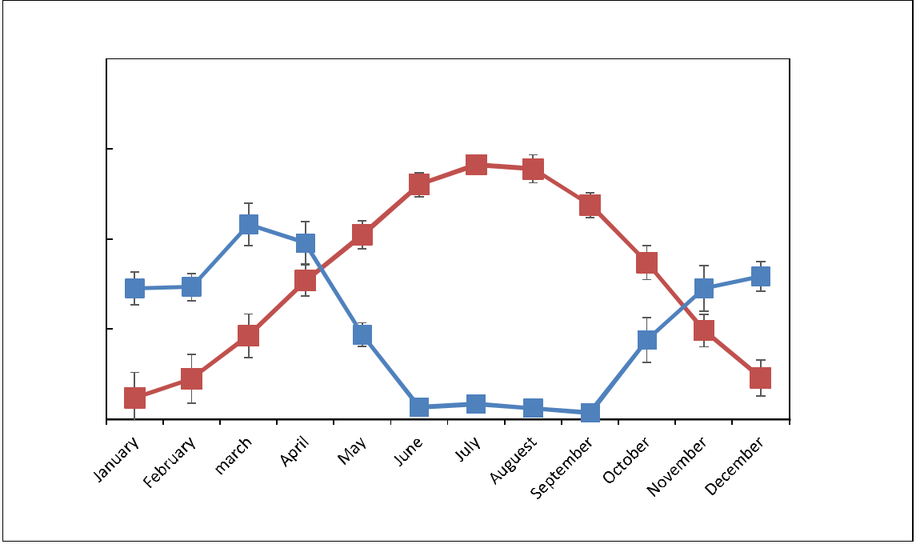

Mean temperature Mean rainfall

|  |  |  |
| --- | --- | --- |
|  | 40 |  |
| (ºC) | 30 |  |
|  |  |
| temperature | 20 |  |
|  |  |
| monthly | 10 |  |
|  |  |
|  | 0 |  |

**Fig. 1** Mean temperature and rainfall in the case study

80

60

|  |  |
| --- | --- |
|  | (mm) |
| 20 | monthlyrainfall |
| 40 |  |

0

The experiment was carried out in randomized complete block design (RCBD) with three replications during 2017 and 2018. Seeds of *S.* *macrantha* L. were sown in the foam trays filledwith a mixture of peat moss and vermiculite (1:1 volume). Two-month seedlings were transplanted in the open field at a spacing of 50 cm (row to row)

* 50 cm (plant to plant) during March 2017 and

2018. Inorganic fertilizer (N, P, and K) were applied utilizing urea (N 50%). The crop was irrigated at 7 days interval with 50 mm irrigation water during non-rainy season.

Chlorophyll Content and Total Soluble Sugar (TSS)

fresh weight, DW is the dry weight of leaves and TW is the turgid weight of leaves after soaking in water [17].

Essential Oil (EO) Extraction

In order to identify the EO content, during peak flowering season, 100 g of dried aerial parts from each treatment were hydrodistilled in the Clevenger type apparatus for 3 hr. The EO content was measured and reported as v/w percentage. The EO yield (kg ha−1) was measured with multiplying the EO content with the plant yield of the experimental treatments [18].

Statistical Analysis

Chlorophyll content (mg g−1 fresh weight of leaves) was measured through organic solvent (80% acetone) extraction method as described by Arnon [15].The supernatant was used for TSS estimation by using anthrone reagent as described by Mc Cready *et al.* [16].

Relative Water Content (RWC)

To determine the RWC of leaf, some leaves of each plant were immersed for 48 hours in distilled water after being weighed. Then the leaves were dried with paper napkins and weighed. The samples were oven dried at 70°C for 48 h and their dry weight was measured. RWC was obtained according as: RWC= [(FW-DW)/ (TW-DW)], where FW is leaf

The data (*n* = 3) were subjected to one-way analysis of variance (ANOVA) and using the SAS software package for Windows (SAS, version 9.3, SAS Institute, Cary, NC). When statistical

significance (*p* < 0.05) was detected, the mean values subjected to Duncan’s multiple range tests.

**Result and Discussion**

Plant Growth

Plant height was influenced by soil amendments and year (*P*≤0.05, table 1). In first year, the

simultaneous application of VC and NPK increased the plant height by 70% compared to control. This

|  |  |
| --- | --- |
| **Journal of Medicinal Plants and By-products (2020) 1: 9-17** | **12** |

increase for NPK and VC was 28% and 44%, respectively. In second year, the plant height significantly increased with the simultaneous use of VC and NPK as 1.07 fold compared to control (table 2). The number of branch per plant was

significantly affected by year, soil amendment and the interaction of year and soil application (*P*≤0.05,

table 1). The maximum branches per plant were found in the NPK and VC application in second year to be 27 branches. In contrast the minimum branches per plant were observed in control in first year as 5 branches (Table 2). Crown area was

significantly changed by year, soil amendment and the interaction of year and soil application (*P*≤0.05,

table 1). In second year, the application of VC, NPK, VC and NPK, VC and TB, and AMF improved the crown area by 32%, 44%, 82%, 39%, and 22%, respectively in comparison with control

(table 2). Plant yield was only influenced by soil amendment (*P*≤0.05, table 1). The highest increase

of plant yield was found in the application of VC and NPK followed by VC and TB, NPK, VC, TB and S 500, and AMF (Table 2).

VC and NPK improved the growth and yield of *S*. *macrantha* Growth and development of plants isdue to the humic acids and micro and macronutrients presented in VC [10,19]. The highest increase in plant height of *Matricaria* *chamomilla* L. was observed by application of 20

t/ha VC [20]. The plant height of maize significantly increased in peat moss amended with

VC supplemented with different concentrations of AMF (*Glomus fasciculatum and Glomus* *claroideum*) and diazotrophic bacteria [21]. Singh *et al.*[22] obtained the highest plant height ofpotato (*Solanum tuberosum* L.) under the combination of VC and NPK fertilizer. VC increased plant height of *Abelmoschus esculentus* (L.) Moench as compared to untreated soil and soil amended with recommended amount of chemical fertilizers [23]. There was an increase in plant height of Crossandra (*crossandra undulatifolia*) in pots treated with water hyacinth VC as compared to the control pots and pots under water hyacinth compost [24].

In our work, VC and NPK improved the plant yield of *S*. *macrantha*. In similar studies, increases in yields by VC applications in ladiy's *fingers* [25], eggplant [26], cucumber [27], *Abelmoschus* *esculentus* [23], peppers [28], crossandra [24],lettuce [29], and wheat [30]. Availability of nitrogen increases growth and leaf area index of

plant which in turn increases absorption of light leading to more dry matter and yield [31]. VC increased growth and yield of various plants because of high porosity, aeration, drainage, and water-holding capacity, presence of beneficial microflora, nutrients such as nitrates, phosphates, and exchangeable calcium and soluble potassium and Plant growth regulators [32].

Chlorophyll Content

Chlorophyll a + b was significantly changed with year and soil amendment (*P*≤0.05, Table 1).

Combined amount of treatments enhanced the chlorophyll content over the control gradually. Stimulators application of VC and NPK fertilizer reached the highest chlorophyll content (table 3). The plant productivity depends on the photosynthesis process, which in turn depends on the chlorophyll content of leaves in plants [4]. The significant differences in the level of total chlorophyll content of medic savory leaves induced by the various chemical and bio fertilizers with respect to control can be due to variable rate of fertilizers in symbiosis with plant and the effect of chlorophyll component. For example, it is reported that VC significantly increased uptake of Mg+2 from the soil [6]. NPK fertilizer due to its sufficient N and P has a key role in increasing the chlorophyll content. In addition, VC can improve the stability of the photosynthetic rate in plants [33]. Our data suggested application of VC and NPK improved photosynthesis in medic savory. Hosseinzadeh *et* *al*. [34] reported an increase of chlorophyll contentin chickpea under VC application. VC due to its porous has a high capacity for ventilation and water storage, which would limit stomata closure and

enhance the CO2 supply required for photosynthesis. The physical, chemical, and biological structures of the VC increased transpiration rate, which is associated with an increase in plant water availability [35]. VC because of its high water-holding capacity increases the amount of water absorbing by plant root [33].

Total Soluble Sugar (TSS)

TSS was significantly affected by year, soil amendment, and their interaction (*P*≤0.05, table 1).

|  |  |  |  |  |  |  |  |  |  |  |  |  |  |  |  |  |  |  |  |  |
| --- | --- | --- | --- | --- | --- | --- | --- | --- | --- | --- | --- | --- | --- | --- | --- | --- | --- | --- | --- | --- |
|  | **13** |  |  |  |  |  |  |  |  |  |  |  |  |  |  | **Bakhtiari *et al*.** | | |  |  |
|  | **Table 1** Analysis of variance for studied traits under soil amendments during 2017 and 2018 | | | | | | | | | | | | |  |  |  |  |  |  |  |
|  |  |  |  |  |  |  |  |  |  |  |  |  |  |  |  |  |  |  |  |  |
|  | S.O. | df |  | MS |  |  |  |  |  |  |  |  |  |  |  |  |  |  |  |  |
|  |  |  |  |  |  |  |  |  |  |  |  |  | |  |  |  |  |  |  |  |
|  |  |  |  | Plant |  | Branch |  | Crown area | plant yield |  | Chl. a+b | Chl. a:b | | TSS |  | RWC |  | EO |  | EO |
|  |  |  |  | height |  | number |  |  |  |  |  |  |  |  |  |  |  |  |  | yield |
|  |  |  |  |  |  | |  | |  |  | |  |  |  |  |  |  | |  | |
|  | Year | 1 |  | 108.9 ns |  | 874 ** |  | 4346340 ** | 42965 ns |  | 0.017 * | 0.69 | ** | 79.9 | ** | 17.7 ns |  | 1.06 ** |  | 240.8 * |
|  | Year (rep) | 4 | 122.5 ** | | 9.8 * | |  | 58585 ns | 276233 ** | 0.001 ** | | 0.003 ns | | 0.69 | * | 3.18 ns | 0.08 ** | |  | 18.3 ns |
|  | Soil amendments | 8 | 145.4 ** | | 85.3 ** | | 2901303 ** | | 1876083 | 0.01 ** | | 0.07 | * | 11.7 | ** | 59.8 ** | 0.95 ** | | 1347 ** | |
|  |  |  |  |  |  |  |  |  | ** |  |  |  |  |  |  |  |  |  |  |  |
|  | Year*Soil | 8 |  | 6.85 ns | 10.4 ** | | 160682 ** | | 58595 ns |  | 0.0007 ns | 0.05 | * | 0.89 | ** | 3.54 ns | 0.03 * | |  | 18.1ns |
|  | amendments |  |  |  |  |  |  |  |  |  |  |  |  |  |  |  |  |  |  |  |
|  | Error | 32 | 4.5 | | 3.05 | | 15779 | | 69943 | 0.001 | | 0.02 |  | 0.2 |  | 3.14 | 0.017 | | 20.4 | |
|  | CV | - | 8.4 | | 13.91 | | 8.6 | | 13.1 | 4.1 | | 7.7 |  | 2.83 |  | 2.44 | 10.7 | | 17.6 | |
|  |  |  |  |  |  |  |  |  |  |  |  |  |  |  |  |  |  |  |  |  |

**, *, and ns represent the significance at 1%, 5% probability levels, and no significant difference, respectively.

**Table 2** The effect of different soil amendments on plant growth of medic savory. VC: Vermicompost, TB: thiobacillus, S:

Sulfur, AMF: Arbuscular mycorrhizal fungi

|  |  |  |  |  |  |  |  |  |  |  |  |  |  |  |  |
| --- | --- | --- | --- | --- | --- | --- | --- | --- | --- | --- | --- | --- | --- | --- | --- |
|  | Year |  | Soil amendment |  | Plant height (cm) | |  | Branch | number |  | Crown area (cm-2) | |  | Plant yield (kg ha-1) | |
|  |  |  |  |  |  |  |  | per plant | |  |  |  |  |  |  |
|  |  |  |  |  |  |  |  |  |  |  |  | |  |  |  |
|  | First year |  | control | 18.5±1.7 | | ij | 5.0±0.7 | | h |  | 783±67 h | | 995±108 | | f |
|  |  |  | NPK |  | 23.8±2.2 d-j | |  | 11.2±1.1 f | | 1296±95 | | d-g |  | 2048±282 bc | |
|  |  |  | VC |  | 26.6±2.5 c-f | |  | 10.3±1.5 fg | | 1230±92 | | e-g |  | 2348±ab | ab |
|  |  |  | NPK+ VC |  | 31.6±2. 4 a-c | |  | 12.2±2. 1 d-f | |  | 1373± 91 d-f | | 2798±283 | | a |
|  |  |  | VC +TB |  | 27.1±1.7 b-e | |  | 11.0±1.2 f | | 1103±75 | | g | 2436±207 | | ab |
|  |  |  | TB |  | 20.5±2.0 f-j | | 6.7±0.8 | | h | 1233±97 | | d-g | 1753±145 | | c-e |
|  |  |  | TB + S250 |  | 22.8±1.9 e-j | | 7.1±0.9 | | h |  | 1276±101 d-g | |  | 1791±178 cd | |
|  |  |  | TB + S500 |  | 23.8±2.2 d-j | | 7.6±0.9 | | gh | 1160±99 | | d-g | 1791±178 | | cd |
|  |  |  | AMF |  | 20.0±1.8 h-j | | 5.1±0.9 | | gh | 1106±97 | | g | 1376±108 | | d-f |
|  | Second year |  | control | 17.7±1.7 | | j | 10.6±1.4 | | fg | 1386±95 | | d-f | 991±111 | | f |
|  |  |  | NPK |  | 27.7±1.7 b-e | | 16.6±1.7 | | bc | 1833±127 | | bc | 2466±245 | | ab |
|  |  |  | VC |  | 29.4±3.2 b-d | |  | 19.0±1.5 b | | 2000±109 | | b | 2101±287 | | bc |
|  |  |  | NPK+ VC | 36.1±2.1 | | a | 27.0±1.8 | | a | 2533±121 | | a | 2466±283 | | ab |
|  |  |  | VC +TB | 33.2±2.3 | | ab | 19.6±1.6 | | b | 1930±105 | | b | 2483±315 | | ab |
|  |  |  | TB |  | 24.2±2.1 d-i | |  | 14.6±1.5 c-e | | 1416±101 | | de | 1495±173 | | de |
|  |  |  | TB + S250 |  | 25.2±2.7 d-g | |  | 14.6±1.9 c-e | | 1470±88 | | d | 1683±129 | | c-e |
|  |  |  | TB + S500 |  | 26.3±2.4 c-g | | 15.3±1.6 | | cd | 1400±112 | | de | 1718±125 | | c-e |
|  |  |  | AMF | 20.2±1.8 | | g-j | 11.6±1.7 | | e-f | 1700±98 | | c | 1283±125 | | ef |
|  | S.O. |  |  |  |  |  |  |  |  |  |  |  |  |  |  |
|  | Year (Y) |  |  | ** | |  | ** | |  | ** | |  |  | ns |  |
|  | Fertilization treatment (F) |  |  | ** | |  | ** | |  | ** | |  | ** | |  |
|  | Y*F |  |  |  | ns |  | ** | |  | ** | |  |  | ns |  |
|  | Error |  |  |  |  |  |  |  |  |  |  |  |  |  |  |
|  | CV |  |  |  |  |  |  |  |  |  |  |  |  |  |  |
|  |  |  |  |  |  |  |  |  |  |  |  |  |  |  |  |

In both years, soil amendments used in our study gradually increased the TSS over the control (table 3). However, VC separately or in combination with NPK gave the higher TSS compared to other experimental treatments (table 3). Similar to our findings, the improvement of TSS under VC application has been reported on *Sideritis montana*

1. and mustard plant [8]. Higher biosynthesis of chlorophyll and photosynthesis results in higher amount of TSS content in leaves. Bio fertilizers promote the biosynthesis of carbohydrates in leaves
2. The improved levels of sugar are directly correlated with such physiological processes like photosynthesis, translocation and respiration. In second year, NPK fertilizer increased the TSS by 15% which was attributed to N and P supply in photosynthesis and accumulation of higher TSS. Similar results were obtained in mulberry leaves by Setua *et al.* [38]. Kumar *et al*. [39] indicated that use of organic and bio fertilizers due to its potential on holding soil moisture and nutrients availability

|  |  |
| --- | --- |
| **Journal of Medicinal Plants and By-products (2020) 1: 9-17** | **14** |

increases the TSS of strawberry, which is in agreement with our results.

Relative Water Content (RWC)

RWC was changed by year and soil amendments (*P*≤0.05, table 1). In first year, the combination of

VC and NPK increased RWC by 14% compared to control (table 3). The application of organic fertilizers improves the water capacity of plant cells and maintains turgor pressure of leaves via adjusting the stomatal guard cells. VC and most bio-fertilizers have some useful hormones and nutrients playing an important role in stomatal regulation [40]. Hence, in our study, VC due to containing plant hormones, organic ions, porous structure and high water holding potential could effectively improve the RWC of medic savory leaves. Beykkhormizi *et al*. [40] observed the increased RWC of bean plants supplied with VC application on bean under salinity stress. Similarly, Khosravi Shakib *et al*. [41] reported a significant increase of RWC in pot marigold under VC and manure application.

EO Content and Yield

EO content and yield gradually increased by soil amendment application over the control (Fig. 2 and 3). The simultaneous use of VC and NPK increased both EO content and yield higher than other soil amendments.

The similar finding were observed in previous studies, where significantly higher EO content and yield observed in satureja plants supplied with VC, sulfur, AMF such as *Glomus*, *fasciculatum*, *G.* *intraradices* and *G. mosseae*, and plant growthpromoters like *Pseudomonas fluorescens* and *Bacillus subtilis* [12,42,43]. Similarly, Singh *et al.*[44] showed that the simultaneous application of75% VC and 25% NPK fertilizer results in the highest EO yield. These results can be explained in the light of facts that using soil amendments allows increasing organic matter, availability of nutrients, nitrogen fixation and rizosphere microorganisms that release phytohormones, and substances. It leads to increased growth and dry matter accumulation which in turn increases the EO concentration and yield [45].

**Table 3** The effect of different soil amendments on chlorophyll content, total soluble sugar (TSS), and relative water content(RWC) of medic savory during 2017-2018. VC: Vermicompost, TB: thiobacillus, S: Sulfur, AMF: Arbuscular mycorrhizal fungi

|  |  |  |  |  |  |  |  |  |  |
| --- | --- | --- | --- | --- | --- | --- | --- | --- | --- |
|  | Year |  | Treatment | Chl. a+b (mg g-1 |  | Chl. a:b |  | TSS (mg g-1) | RWC (%) |
|  |  |  |  | FW) |  |  |  |  |  |
|  |  |  |  |  |  |  |  |  |  |
|  | First year |  | control | 0.85±0.02 i |  | 2.17±0.08 b-e |  | 8.06±0.6 g | 69.66±1.0 ef |
|  |  |  | NPK | 0.92±0.04 c-h |  | 2.00±0.07 e |  | 9.00±0.4 f | 71.00±1.2 c-e |
|  |  |  | VC | 0.98±0.02 a-d |  | 2.22±0.10 bc |  | 13.00±0.5 b | 76.00±1.5 ab |
|  |  |  | NPK+ VC | 0.95±0.02 a-e |  | 2.29±0.09 b-e |  | 13.06±0.6 b | 79.00±1.4 a |
|  |  |  | VC +TB | 0.90±0.02 e-i |  | 2.74±0.07 a |  | 11.90±0.4 c | 72.00±1.1 c-e |
|  |  |  | TB | 0.87±0.03 g-i |  | 2.36±0.09 bc |  | 9.86±0.3 c | 68.33±0.9 f |
|  |  |  | TB + S250 | 0.87±0.03 g-i |  | 2.33±0.10 bc |  | 10.36±0.7 de | 71.00±1.0 c-e |
|  |  |  | TB + S500 | 0.84±0.02 i |  | 2.34±0.07 b-d |  | 10.76±0.7 de | 69.33±0.9 d-e |
|  |  |  | AMF | 0.96±0.02 a-e |  | 2.44±0.05 b |  | 9.93±0.4 e | 72.34±1.2 c-e |
|  | Second year |  | control | 0.87±0.03 g-i |  | 2.01±0.06 e |  | 11.00±0.5 d | 70.67±1.1 d-f |
|  |  |  | NPK | 0.91±0.02 d-i |  | 2.06±0.06 c-e |  | 12.73±0.4 bc | 70.33±1.0 ef |
|  |  |  | VC | 1.02±0.02 a |  | 2.12±0.07 b-e |  | 14.53±0.5 a | 77.00±1.5 ab |
|  |  |  | NPK+ VC | 0.99±0.03 a-c |  | 2.12±0.07 b-e |  | 14.46±0.4 a | 78.00±1.3 a |
|  |  |  | VC +TB | 0.94±0.03 b-f |  | 2.05±0.08 c-e |  | 14.13±0.7 a | 74.33±1.2 bc |
|  |  |  | TB | 0.93±0.02 b-g |  | 2.10±0.09 c-e |  | 12.66±0.5 bc | 72.00±1.1 c-e |
|  |  |  | TB + S250 | 0.92±0.03 c-h |  | 2.11±0.08 c-e |  | 12.62±0.5 bc | 70.33±1.1 f |
|  |  |  | TB + S500 | 0.91±0.02 d-i |  | 2.11±0.07 c-e |  | 12.66±0.4 bc | 71.33±1.1 c-f |
|  |  |  | AMF | 1.00 ±0.03 ab |  | 2.19±0.08 b-e |  | 13.03±0.6 b | 74.00±1.3 b-d |
|  | Significance |  |  |  |  |  |  |  |  |
|  | Year (Y) |  |  | ** | ** | | ** | | * |
|  | Fertilization treatment (F) | | | ** | * | | ** | | ** |
|  | Y*F |  |  | ns | * | | ** | | ns |
|  |  |  |  |  |  |  |  |  |  |

**15** **Bakhtiari *et al*.**

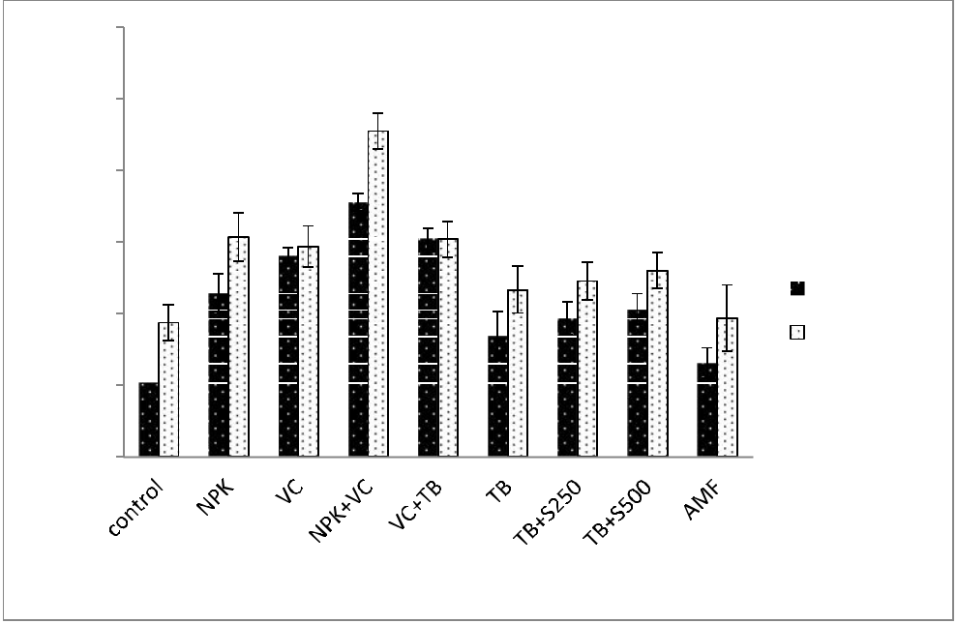

|  |
| --- |
| **EO (%)** |

|  |  |  |  |  |  |  |  |  |
| --- | --- | --- | --- | --- | --- | --- | --- | --- |
| 3 |  |  |  |  |  |  |  |  |
| 2.5 |  |  | a |  |  |  |  |  |
| 2 | c | cd | b |  |  |  |  |  |
|  | c c |  |  |  |  |  |
|  |  |  |  | c-e |  |  |
| 1.5 |  | c-e |  | e-g | e-f | f-h |  |
| e-g |  |  |  |  |
|  |  |  |  | f-h |  |
|  |  |  |  | f-h | first year |  |
| 1 | gh |  | i |  |  |
|  |  |  |  | j | second year |  |
|  |  |  |  |  |  |  |

j

0.5

0

**fertilizer treatments**

**Fig. 2** The effect of different soil amendments on essential oil (EO) content of medic savory during 2017-2018. VC:

Vermicompost, TB: thiobacillus, S: Sulfur, AMF: Arbuscular mycorrhizal fungi

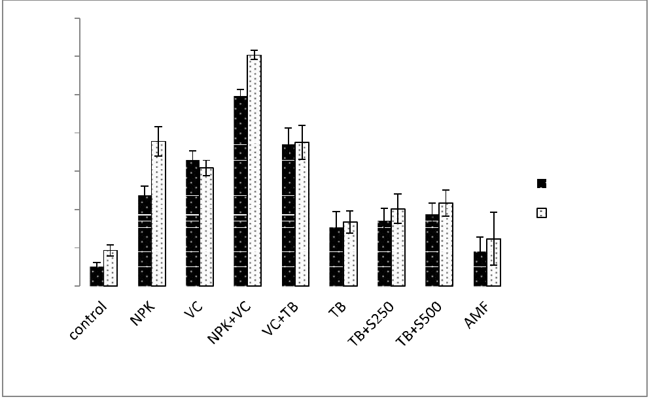

|  |
| --- |
| **EO yield (kg/ha)** |

|  |  |  |  |  |  |  |  |  |
| --- | --- | --- | --- | --- | --- | --- | --- | --- |
| 70 |  | a |  |  |  |  |  |  |
|  |  |  |  |  |  |  |  |
| 60 |  |  |  |  |  |  |  |  |
| 50 |  | b |  |  |  |  |  |  |
| c | c c |  |  |  |  |  |  |
|  |  |  |  |  |  |  |
| 40 |  | c cd |  |  |  |  |  |  |
| 30 | c |  | e-g | ef |  | g-i | first year |  |
|  | f-h |  |  |
|  |  | e-h |  |  |  |
| 20 |  | e-h | e-h |  |  |  | second year |  |
| hi |  |  |  | hi |  |  |
|  |  |  |  |  |  |  |
|  |  |  |  |  |  |  |  |
| 10 | j |  |  |  |  |  |  |  |
| 0 |  |  |  |  |  |  |  |  |
|  |  |  |  |  |  |  |  |

**fertilizer treatments**

**Fig. 3** The effect of different soil amendments on essential oil (EO) yields of medic savory during 2017-2018. VC:

Vermicompost, TB: thiobacillus, S: Sulfur, AMF: Arbuscular mycorrhizal fungi

**Conclusions**

The present work was carried out to assess the effect of different soil amendments (chemical fertilizer, VC, AMF, S, and TB) on plant growth, physiological and biochemical properties of medic savory. We found that the growth, chlorophyll

content, EO content and yield was gradually increased by application of these amendments. However, the combination of VC and NPK was remarkably higher than other amendments. Other amendments particularly sulfur and AMF did not make a significant effect on the medic savory. Hence, according to our results, the simultaneous

|  |  |
| --- | --- |
| **Journal of Medicinal Plants and By-products (2020) 1: 9-17** | **16** |

application of VC and NPK fertilizer is the best strategy to reach the optimum growth and EO yield of medic savory.

**References**

1.Gohari AR, Hadjiakhoondi A, Sadat-Ebrahimi E, Saeidnia S, Shafiee A. Cytotoxic terpenoids from *Satureja macrantha* CA Mey. Daru J Pharm Sci.

2005;13:177-181.

1. Saharkhiz MJ, Zomorodian K, Taban A, Pakshir K, Heshmati K, Rahimi MJ. Chemical composition and antimicrobial activities of three Satureja species against

food-borne pathogens. J Essent Oil Bear Plant.

2016;19:1984-1992.

3. Sefidkon F, Jamzad Z, Chemical composition of the essential oil of three Iranian Satureja species (*S. mutica,*

*S. macrantha* and *S. intermedia*). FoodChem. 2005;91:1-4.

1. Banerjee A, Datta JK, Mondal NK, Chanda T. Influence of integrated nutrient management on soil

properties of old alluvial soil under mustard cropping system. Communi Soil Sci Plant Anal. 2011;42:2473-

2492.

5. Garai TK, Datta JK, Mondal NK. Evaluation of integrated nutrient management on boro rice in alluvial

soil and its impacts upon growth, yield attributes, yield and soil nutrient status. Arch Agron Soil Sci. 2014;60:1-

14.

1. Mondal T, Datta JK, Mondal NK. Chemical fertilizer in conjunction with biofertilizer and vermicompost induced

changes in morpho-physiological and bio-chemical traits of mustard crop. J Saudi SocAgr Sci. 2017;16:135-144.

7. Ignacimuthu S, Vendan, SE. Botanical pesticides in

insect pest management. Uttar Pradesh J Zoo.

2007;4:141-154.

8. Ju I, Wj B, Md S, Ia O, Oj E. A review: Biofertilizer-A

key player in enhancing soil fertility and crop productivity. J Microbiol Biotechnol Report. 2018;2:234-

239.

1. Prasad H, Sajwan P, Kumari M, Solanki SPS. Effect of organic manures and biofertilizer on plant growth, yield

and quality of horticultural crop: A review. IntJChem Stud. 2017;5:217-221.

1. Carreón -Abud Y, Torres-Martínez R, Farfán-Soto B, Hernández-García A, Ríos-Chávez P, Bello-González M, Salgado-Garciglia R. Arbuscularmycorrhizal symbiosis increases the content of volatile terpenes and plant performance in *Satureja macrostema* (Benth.) Briq.

Boletín Latino Americano y del Caribe de Plantas Medicinales y Aromáticas. 2015;14:273-279.

11. Wicaksono WA., Sansom CE, Jones EE, Perry NB,

Monk J, Ridgway HJ. Arbuscular mycorrhizal fungi associated with Leptospermum scoparium (mānuka):

effects on plant growth and essential oil content.

Symbiosis. 2018;75:39-50.

12.Hossaini SM, Aghaalikhani M, Sefidkon F, Ghalavand, A. Effect of Vermicompost and planting pattern on oil production in *Satureja sahendica* L. under Competition

with pigweed (*Amaranthus retroflexus* L.). J Essent Oil Bear Plant. 2016;19:606-615.

1. Dube L, Naidoo KK, Arthur GD, Aremu AO, Gruz J, Šubrtová M, DoležalK. Regulation of growth, nutritive, phytochemical and antioxidant potential of cultivated *Drimiopsis maculata* in response to biostimulant

(vermicompost leachate, VCL) application. Plant Growth Regul. 2018;86:433-444.

1. Oloyede F, Agbaje GO, Obisesan IO.Effect of NPK fertilizer on fruit yield and yield components of pumpkin

(*Cucurbita pepo* Linn.). Afr J Food Agr Nutr Develop.

2013;13:24-32.

15. Arnon DI. Copper enzymes in isolated chloroplasts.

Polyphenoloxidase in *Beta vulgaris*. Plant Physiol.

1949;24:1-9.

16. McCready RM, Guggolz J, Silviera V, Owens HS.

Determination of starch and amylose in vegetables. Anal Chem. 1950;22:1156-1158.

1. Bian S, Jiang Y. Reactive oxygen species, antioxidant enzyme activities and gene expression patterns in leaves

and roots of Kentucky bluegrass in response to drought stress and recovery. Sci Hort. 2009;120:264-270.

18. Sifola MI, Barbieri G. Growth, yield and essential oil

content of three cultivars of basil grown under different levels of nitrogen in the field. Sci Hort. 2006;108:408-

413.

1. Fernández-Luqueño F, Reyes -Varela V, Martínez-Suárez C, Salomón -Hernández G, Yáñez -Meneses J, Ceballos-Ramírez JM, Dendooven L. Effect of different nitrogen sources on plant characteristics and yield of

common bean (*Phaseolus vulgaris* L.). Bioresour Technol. 2010;101:396-403.

20.Hadi MRHS, Darz M.T, Gh Z, Riazi G. Effects of vermicompost and amino acids on the flower yield and

essential oil production from Matricaria chamomile L. J Med Plant Res. 2011;5:5611-5617.

1. Gutiérrez-Miceli FA, Moguel-Zamudio B, Abud-Archila M, Gutiérrez-OlivaVF, Dendooven L. Sheep manure vermicompost supplemented with a native

diazotrophic bacteria and mycorrhizas for maize cultivation. Bioresour Technol. 2008;99:7020-7026.

1. Singh B, Pathak K, Boopathi T, Deka B. Vermicompost and NPK fertilizer effects on morpho-physiological traits of plants, yield and quality of tomato

fruits:(*Solanum lycopersicum* L.). Veg Crop Res Bul.

2010;73:77-86.

1. Vijaya KS, Seethalakshmi S. Response of eggplant (*Solanum melongena* L.) to integrated nutrient management amended soil (No. RESEARCH). 2011.
2. Gajalakshmi S, Abbasi SA. Effect of the application of water hyacinth compost/vermicompost on the growth and

flowering of *Crossandra undulaefolia*, and on several vegetables. Bioresource Technol. 2002;85:197-199

1. Ansari AA, SukhrajK. Effect of vermiwash and vermicompost on soil parameters and productivity of

**17** **Bakhtiari *et al*.**

okra (*Abelmoschus esculentus*) in Guyana. Afr J Agr Res. 2010;5:1794-1798.

1. Moraditochaee M, Bozorgi HR, Halajisani N. Effects of vermicompost application and nitrogen fertilizer rates

on fruit yield and several attributes of eggplant (*Solanum* *melongena* L.) in Iran. World ApplSci J. 2011;15:174-

178.

1. Azarmi R, Giglou MT, Hajieghrari B. The effect of sheep-manure vermicompost on quantitative and

qualitative properties of cucumber (*Cucumis sativus* L.) grown in the greenhouse. Afr J Biotechnol. 2009;8:21-

28.

1. Arancon NQ, Edwards CA, Bierman P, Metzger JD, Lucht C. Effects of vermicomposts produced from cattle

manure, food waste and paper waste on the growth and yield of peppers in the field. Pedobiologia, 2005;49:297-

306.

1. Papathanasiou, Papadopoulos I, Tsakiris I, Tamoutsidis E. Vermicompost as a soil supplement to improve

growth, yield and quality of lettuce (*Lactuca sativa* L.). J Food Agr Environ. 2012;10:677-682.

1. Joshi R, Vig AP, Singh J. Vermicompost as soil supplement to enhance growth, yield and quality of

Triticumaestivum L.: a field study. Int J Recyc Organic Waste Agr. 2013;2:16-21.

31.Grogan P, Zamin TJ. Growth responses of the common arctic graminoid *Eriophorum vaginatum* to simulated grazing are independent of soil nitrogen availability.

Oecologia. 2018;186:151-162.

1. Edwards CA. Burrows I. Potential of earthworm composts as plant growth media. Earthworms in waste and environmental management/edited by Clive A. Edwards and Edward F. Neuhauser.1988.

33.Atik A. Effects of planting density and treatment with vermicompost on the morphological characteristics of

oriental beech (*Fagus orientalis* Lipsky.). Compost Sci Util. 2013; 21:87-98.

1. Hosseinzadeh SR, Amiri H, Ismaili A. Effect of vermicompost fertilizer on photosynthetic characteristics

of chickpea (*Cicer arietinum* L.) under drought stress.

Photosynthetica. 2016;54:87-92.

1. Yang L, Zhao F, Chang Q, Li T, Li F. Effects of vermicomposts on tomato yield and quality and soil

fertility in greenhouse under different soil water regimes.

Agr Water Manag. 2015;160:98-105.

1. El-Sherbeny SE, Khalil MY, Naguib NY. Influence of compost levels and suitable spacing on the productivity of *Sideritis montana* L. plants recently cultivated under

Egyptian conditions. Bull Fac Agric Cairo Univ.

2005;56:373-392.

37.Aseri GK, Jain N, Panwar J, Rao AV, Meghwal PR. Biofertilizers improve plant growth, fruit yield, nutrition, metabolism and rhizosphere enzyme activities of

pomegranate (*Punica granatum* L.) in Indian Thar Desert. Sci Hort. 2008;117:130-135.

38.Setua GC, Das NK, Banerjee ND, Sengupta T, Sudhakar P, Sen S, Saratchandra B. Effect of integrated nutrient management on quality leaf production in

mulberry (*Morusalba*) under rainfed, alluvial soil conditions. India J Agr Sci. 2005;75:474-478.

1. Kumar N, Singh HK, Mishra PK.Impact of organic manures and biofertilizers on growth and quality

parameters of Strawberry cv. Chandler. Ind J Sci Technol. 2015;8:1-6.

1. Beykkhormizi A, Abrishamchi P, Ganjeali A, Parsa, M. Effect of vermicompost on some morphological, physiological and biochemical traits of bean (*Phaseolus*

*vulgaris* L.) under salinity stress. J Plant Nut.

2016;39:883-893.

41. Khosravi Shakib, A, Rezaei Nejad, A, KhandanMirkohi, A, KalateJari, S. Vermicompost and Manure Compost Reduce Water-Deficit Stress in Pot

Marigold (*Calendula officinalis* L. cv. Candyman Orange). Compost Sci Util. 2019;27:61-68.

1. Zahedifar M, Najafian SH. Combined effect of soil applied iron and sulfur fertilisers on monoterpenecontent

and antioxidant activity of *Satureja hortensis* L. Extract.

Pertanika J Trop Agr Sci. 2015;38.

1. Vafa ZN, Sirousmehr AR, Ghanbari A, Khammari I, Falahi N. Effects of nano zinc and humic acid on

quantitative and qualitative characteristics of savory (*Satureja hortensis* L.). Int J Biosci. 2015;6:124-136.

1. Singh R, Singh M, Srinivas A, Rao, EP, Puttanna K. Assessment of organic and inorganic fertilizers for growth, yield and essential oil quality of industrially

important plant patchouli (*Pogostemon cablin*) (Blanco)

Benth. J Essent Oil Bear Plant. 2015;18:1-10.

1. El-Naggar AHM, Hassan MRA, Shaban EH, Mohamed MEA. Effect of organic and biofertilizers on growth, oil yield and chemical composition of the essential oil of

*Ocimum basillicum* L. plants. Alex. J Agric Res.

2015;60:1-16.